**PNEUMATIC PHYSIOTHERAPIC MASSAGER**

**TEAM MEMBERS**

**OBJECTIVES**

* To make an economically affordable massager .
* Which can be used as a basic physiotherapy equipment .
* To relieve muscle pain .
* To help to heal sewlling .
* To help in Aiding insomnia .
* To relieve stress and anxiety .

**INTRODUCTION**

In this fast moving world where the number of actively physically working jobs have been diminishing due to the development of IT sector and most of the people are now just sitting before the monitors for long hours which develops a lot of medical problems, one of which is body ache specifically for hand and leg and hence our aim here is to address this problem and make an smartphone controlled massager which consumes very less energy and is more economical then the current ones .

**LITERATURE SURVEY**

Massage is defined as a skill in which different types of strokes are used to manipulate the soft tissue of whole body in order to provide relaxation and relieve pain. Oncology patients use massage therapy during chemotherapy or radiation therapy . Sims believed that touch is important in nursing profession as it provides comfort and alleviates suffering and communicates caring attitude towards patients. Massage is also a form of touch therapy. It is an ancient form of treatment which started from China, Japan and was later used in India, Arabic nations, Egypt, Greece and Rome .

Those patients who received massage said that it reduced their distress level eased tightness and provided relaxation .

**CONVENTIONAL MASSAGERS**

**Massaging Chair**

A massage chair is fundamentally different from a sofa or recliner. But essentially, they are chairs with mechanisms built-in to massage and relax your muscles through vibrations and heat.

By outward design, they’re similar to what you’d see in a recliner. But there is a lot more going on under the cushions than just balls of cotton.

The original massage chair was invented by a man called Roland A. Labbe in 1948 when he filed a patent for the massage chair. His design was rather simple. He mounted a stool on a pedestal. On the back of the pedestal, there was a metal frame attached to the chair which could vibrate and ease the sitter into comfort.

Modern massage chairs have come a long way since then, with much more advanced features and capabilities.

**Vibrational massager**

Mechanical oscillatory motion provided by vibration therapy. Vibration could represent an effective exercise intervention for enhancing neuromuscular performance in athletes. Vibration has shown effectiveness in flexibility and explosive power. Vibration can apply either local area or whole body vibration. Vibration therapy improves muscular strength, power development, kinesthetic awareness, decreased muscle sore, increased range of motion,VT was effective for reduction of DOMS and regaining full ROM. Application of whole body vibration therapy in postexercise demonstrates less pressure pain threshold, muscle soreness along with less reduction maximal isometric and isokinetic voluntary strength and lower creatine kinase levels in the blood.

**PROPOSED WORK AND METHODOLOGY**

1.) The massager is designed to be a wearable device which can be worn and the person can lie down or can do any small chores.

2.) The massager has two parts a wearable component which raps around the limbs and has a latex blader In it.

3.) The rubber bladder raps around the limbs and the bladder is filled by air from a a compressor which is the other part of the device together this makes up the device .

4.) There will be 8 bladders and each of them will be controlled by a pnuematic valve.

5.) The valves are controlled by the microprocessor and is opened at the programmed timings so that a cyclic pressure is applied on the limb from the bottom to top hence the person receives a massage.

6.) The type of the cyclic operation can changed by changing the executed code and the massager is will also support (IOT) and Bluetooth module and hence can be controlled by the phone by an application developed for this or by the keypad provided .

7.) The massager can also be set for different pressure for each compression and the time of compression speed of the compressor can also altered to get optimum massage for the person using.

8.) By using this excessive use of programming and pressure sensors will also be added to determine pressure of each compression and the pressure can also be set by the application.

9.) Hence this massager can be used for surgical massaging in physiotherapy too.

10.) The device will also have an LCD display for displaying the mode of operation , pressure of operation, speed of each cycle and application time of maximum pressure.

**BLOCK DIAGRAM**

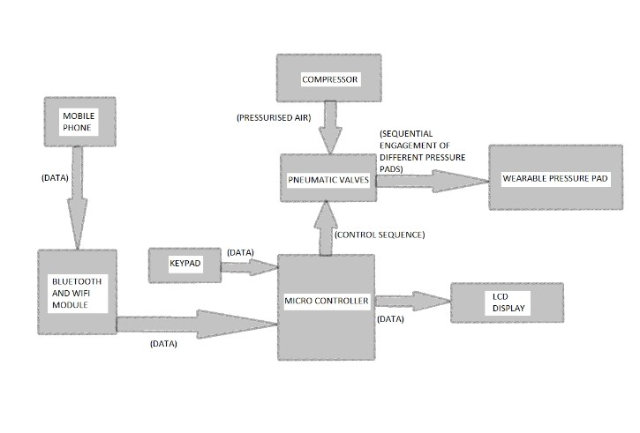

**WORK PLAN**

June - research and ground work and planing of the things to buy.

July - 1st week - buying the necessary things.

2nd week - starting the assembly of the physical model.

August - 3rd week - finishing of the physical prototype.

4th week - adding the pressure sensor and electronic components.

September - 1 st week - adding the microprocessor and LCD display and keypad.

3 rd week - Adding the Bluetooth module and WiFi module for (IOT)

October - 1st week - starting the development of codes for microprocessor.

November - 1st week - testing and fine tuning the massager.

December - 1st week - development of the app for controlling by mobile

**IMPLEMENTATION**

The project is mainly designed to be used by the comman man in their homes without any special knowledge or training.

It is designed and the software for the mobile will be made in such a way that the people can use easily and even the elderly people with very less experience with smart phone can also use this massager.

It can also be used in the massaging centres spa and other places used by the people to relax, it can also be used in the waiting area's lobbies and also be used by the IT companies for the relaxation of their employees.

**RESULT - EXPECTED OUTCOME**

Hence by the use of this project following can be achieved

1.) An economically affordable massager is made .

2.) It can be used as a basic physiotherapic equipment too .

3.) It can relieve muscle pain .

4.) It can help to heal sewlling .

5.) It can help in Aiding insomnia .

6.) It can help to relieve stress and anxiety and aid in relaxation.

**APPLICATIONS**

**1. CAN BE USED AS A HOUSEHOLD PRODUCT**

The massager can be used as a product like normal household appliances like refrigerator,television etc., as the cost was low and it will be very useful for old peoples those who suffer from body pain. Even housewifes can get rid of their body pains due to their works which would be a great relief to them. Children from schools can get rid of their back pains, as their school bags were so heavy for their age. Mens returning from office work can use this massager and can feel little better after coming home, so it can be a stress relief for them. Since the budget of the massager was low, each and every individual can get use of this product in this busy scheduled world.

**2. CAN BE USED IN MASSAGING CENTRES**

Massaging centres can use this product, as this product was cost-efficient and it consumes less input power thereby consuming electricity. Massaging centres and their customers both can get profit due to low cost of the product.

**3. CAN BE USED IN IT COMPANIES FOR EMPLOYEES**

The IT employees who work infront of their systems can experience back pain, in order to get rid of this stress experienced by the employees, IT companies can set up a massing centre like gyms inside their company itself. This setup is not so expensive and requires less maintenance. It can be a great way to reduce the stress of the employees.

**CONCLUSION**

In this busy world, stress is the main factor that we experience from schools till we die. this can't be changed but we can get rid of small part of this stress by getting rid of the body pain we face in our life. This low budget massager can be used by everyone in the world, to reduce one major stress(body pain) we face in our life.

It also be used in physiotherapic precision massaging and hence a low cost massager leads to more people getting access to the treatment.

**REFERENCE**

**1.)** https://www.massagexpert.net/best-handheld- massager-reviews/

**2.)** https://homesthetics.net/how-does-a-massage-chair-work/

**3.)** https://en.wikipedia.org/wiki/Massage

**4.)** https://bestofmachinery.com/best-portable-air-compressor-for-car/

**FINANCIAL ASSISTANCE**

Compressor - 3000

Pneumatic valves - 4000

Microprocessor - 2000

Bluetooth module - 1000

WiFi module - 1000

Rubber bladder - 2000

LCD display and - 1000

keypad

3d printing parts - 4000

Extras - 4000